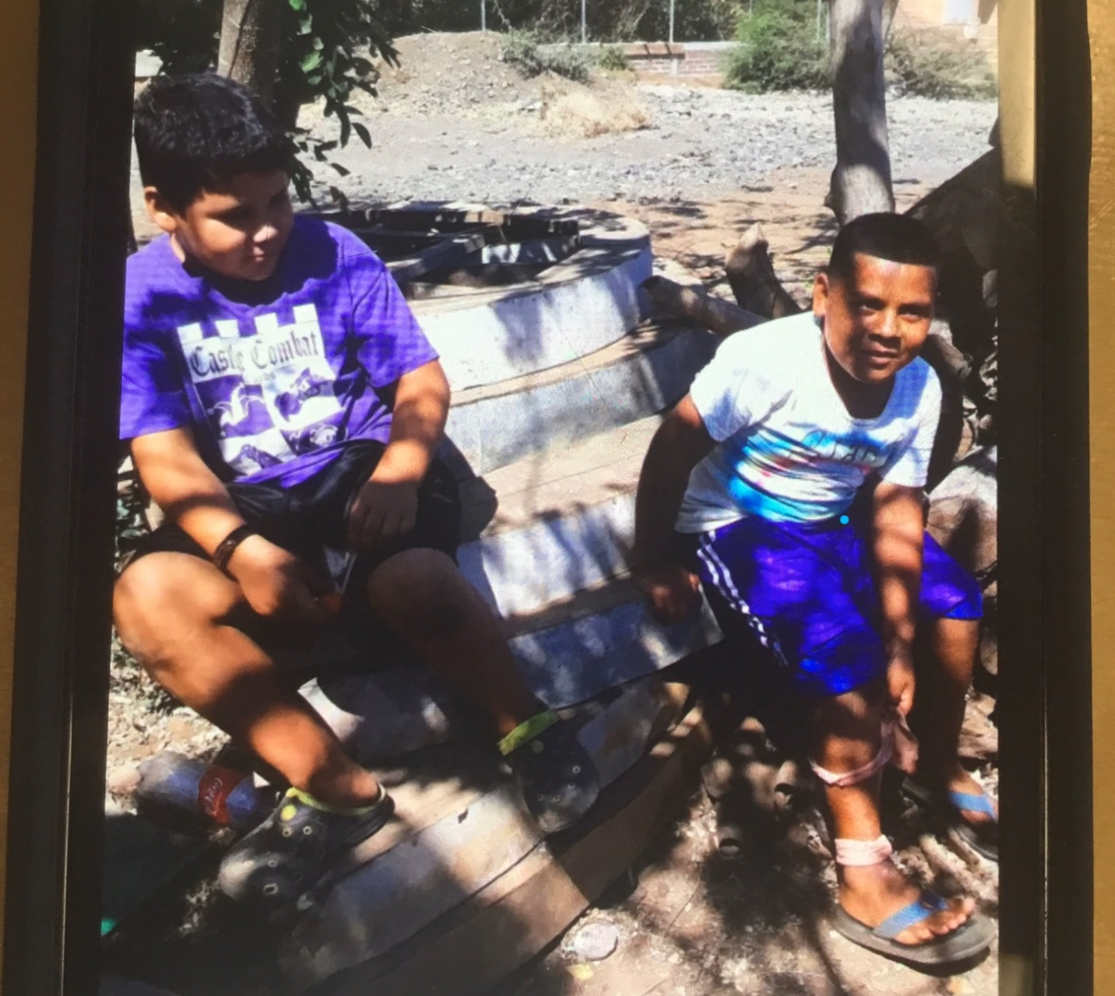

NEW ROOM 10 CARING PROJECT: Room 10 is collecting gently used running shoes and soccer shoes to send to El Salvador with a friend. We are asking all of McNaughton Ave. P. S. to help bring in donations. There are 30+ boys signed up for 2 teams. There is a retired principal (from Waterloo Board) who is teaching English and starting soccer in Barra Ciega, El Salvador. This is her personal give back project but she is recruiting help for running shoes or soccer shoes. You can see from the picture that flip flops or crocs are what they wear but are not sufficient for soccer playing. We will put a bin out at the front of the school for drop off. The boys are 6-16 and she is hoping to start a girl’s club when she can get bike shorts for under their dresses they wear regularly.

In preparation, we read, For Every Child A Better World. We said we love soccer and could see from the book that not everyone can play...especially if they only have flip flops.

